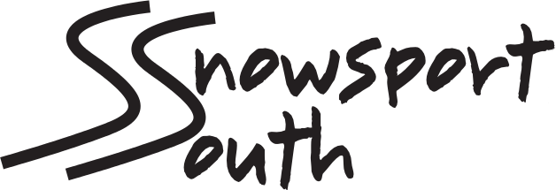

Snowsport South Freestyle Squad Selection 2013
(may be subject to revision)

The Snowsport South Freestyle Squad is committed to promoting Freestyle Skiing and serves as a feeder squad for the elite England and Great Britain Squads. The aim is to coach and nurture young performance athletes to achieve international honours with the ultimate aim being to compete in the World Freestyle Championships and Winter Olympics.
Selection takes place in May each year and is based on results in competition and commitment to training. Results obviously play a large part in deciding squad structure, as it is results in competition that reflect the strength of the squad. Technical ability and commitment obviously play a major role in deciding the longevity of performers in the squads. Results need to be correlated chronologically to ensure maintenance or development of performance.
It is recognised that there are different performance indicators between male and female athletes and we, in line with FIS, recognise this when correlating competition results.
Because freestyle competitions have variable marking schemes between different competitions, only relative performance within one competition can be considered. Therefore, a percentage model is applied.
We also recognise that Freestyle Skiing is a highly technical discipline as it involves All Mountain skills. Therefore competition in and training for Alpine events is also taken into consideration, especially in Moguls and Skier Cross.
There are a number of different national and regional competitions that count towards squad selection. These competitions are those recognized or affiliated to the Home Nations Ski Associations (England, Scotland, Wales, Northern Ireland) and include Slopestyle at SFC Series; the Snow Tour Series held at various UK locations; the Brits in Laax. We do not take into account other local competitions. Please contact Paul Webb (SS South Regional Freestyle rep - Paul@southernfreestyle.co.uk ) for advice if you are unsure.
Please remember selection for a squad is not a right of passage: it must be earned. Because an individual is in a particular squad one year it does not necessarily mean they will remain in that squad in subsequent years. Like any successful sports squad there will be movement in and out of and between squads.
Selection Criteria
To qualify for a particular squad, a performer must have competed in at least 3 events in the year and have made the qualifying standard in at least 2 separate competitions (on different dates).
Snowsport South Freestyle A Squad: (Guide)
Finish in the top 30% of age category (split Male/Female). Achieve podium positions. Compete in most major events in UK and Brits in Laax.
Snowsport South Freestyle B Squad: (Guide)
Finish in the top 60% of age category (split Male/Female). Achieve occasional podium positions and compete in most recognized UK events
Snowsport South Freestyle Development Squad:
Show ability in competition and training.
(Note Only A and B squads will be published)
Training Commitments
It is recognized that some squad members are not local and so not every training session can be attended. However it is expected that squad members will train at least once in every month period (holidays excluded).
Recognized training sessions
These are held at Bracknell Nike ski centre on Sunday Mornings (9.00-11.00 am). Main squad sessions occur on the first Sunday of every Month. Grom Camps are also considered valuable training.
NB
- While athletes are members of any England or GB Squad they become Graduates of the Snowsport South Freestyle Squad. Once National membership ends they may return to the Snowsport South Freestyle Squad so long as selection criteria are achieved.
- Squad members must be members of a Snowsport South affiliated club.

